Portfolio: Aerospace
Division: Aerospace Engine Systems
Work Location: Trollhättan
Legal Employee Entity: GKN Aerospace Sweden AB
Vacancy Title: Master Thesis in Mechanical Engineering
Justification: Andreas Borg

Role Purpose
Om GKN Aerospace:
GKN Aerospace is the aerospace operation of GKN plc, serving a global customer base and operating in North America and Europe. With sales of £2.2 billion in 2014, the business is focused around three major product areas - aerostructures, engine products and transparencies, plus a number of specialist products - electro-thermal ice protection, fuel and flotation systems, and bullet resistant glass. The business has significant participation on most major civil and military programmes. GKN Aerospace is a major supplier of integrated composite structures, offers one of the most comprehensive capabilities in high performance metallics processing and is the world leading supplier of cockpit transparencies and passenger cabin windows.

Key Responsibilities
Proposed thesis title: Prying factor for circular flanges - theory and verification of recommended method
Period of time and amount of credits: 30 credits/20 weeks.
Number of students: 1
Start date: Spring 2018
Uppdragsbeskrivning.
The stiffness of the flange plays an important role of the bolt strength. The prying force Q on the bolts, caused by the flange separation forces depends on the prying factor. Currently a conservative approach is used for the prying factor.

- Review the possibility to use recent improved model for prying factor
- Identify elements to determine the prying factor
- Verify prying factor for applicable geometries and generalize the method
- There are several ways to increase the flange stiffness, attached figures.
- Review the opportunities for optimization with respect to strength to weight ratio.

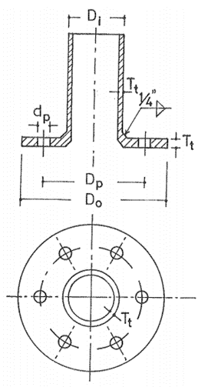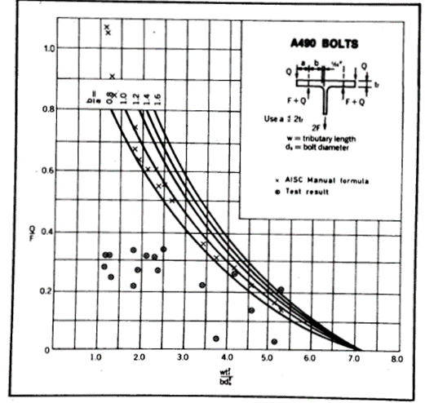
Model by Kato & Hirose Observations by Akerskov

The results expected are:
- Results from a literature study
- Report verification and generalized method

Qualifications/Experience/Skills
Recommended academic background: Mechanical engineering.
Send CV and personal letter to Per Widström (Per.Widstrom@gknaerospace.com)
Function: Employee Type: Intern/Co-op
Advertising start date (External &Internal): 2017-10-05
Advertising end date (External & Internal): 2018-01-15
Prioritise on LinkedIn: Yes

