Portfolio: Aerospace
Division: Aerospace Engine Systems
Work Location: Trollhättan
Legal Employee Entity: GKN Aerospace Sweden AB
Vacancy Title: Master Thesis in Material Science
Justification: Andreas Borg

Role Purpose
Om GKN Aerospace:
GKN Aerospace is the aerospace operation of GKN plc, serving a global customer base and operating in North America and Europe. With sales of £1.5 billion in 2011, the business is focused around three major product areas - aerostructures, engine products and transparencies, plus a number of specialist products - electro-thermal ice protection, fuel and flotation systems, and bullet resistant glass. The business has significant participation on most major civil and military programmes. GKN Aerospace is a major supplier of integrated composite structures, offers one of the most comprehensive capabilities in high performance metallics processing and is the world leading supplier of cockpit transparencies and passenger cabin windows.
Projektbakgrund:
Haynes 282 is a newly developed nickel based superalloy with potential applications in gas turbine applications. There is a need to understand the formation of different phases precipitated in this alloy with temperature and time. The best tool to understand the alloy is by developing a time-temperature transformation diagram. The objective of this work is thus to develop one such tool for this newly introduced material in the superalloy group.

Key Responsibilities
Proposed thesis title: Material Simulations and TTT model for New Superalloy
Period of time and amount of credits: 30 credits/20 weeks.
Number of students: 1
Start date: Spring 2018
Uppdragsbeskrivning.
Develop a experimental Time-Temperature Transformation diagram for the material Haynes 282 and compare it with the Jmat Pro simulation.
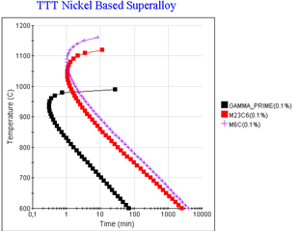

Description of thesis goals and targets.
- Literature review
- Investigate best approach for heat treatment and perform heat treatment to obtain the Time-Temperature transformation diagram.
- Document the results in a thesis Report. (English)
- Present the summary and conclusions for an audience at GKN Aerospace. (English)

Qualifications/Experience/Skills
Recommended academic background: Mechanical engineering or Materials engineering or Physics, including courses on materials.
Send CV and personal letter to Ceena Joseph (ceena.joseph@gknaerospace.com)
Employee Type: Intern/Co-op
Advertising start date (External &Internal): 2017-10-05
Advertising end date (External & Internal): 2018-01-15
Prioritise on LinkedIn: Yes

